Step 1:

First we calculated annual sales per household (not accounting for when households entered the data) as follows:

* + Exclude “KIOSK-GAS” rows from transaction data
  + Create column to indicate whether transaction occurred in year one
  + Compute sum of sales value by household and year

Step 2:

Then we accounted for when households entered the data as follows:

* + Calculate minimum WEEK_NO by household
  + Add earliest week column to the table created in Step 1 by joining on household
  + Split resulting table by year and calculate sales per week in year 1 as SUM_SALES/ (51-EARLIEST_WEEK) and sales per week in year 2 as SUM_SALES/ 51 and then rejoin the two tables on household key
  + Create column to indicate weather sales per week is greater in year two

The resulting table has 2474 households: 1337 that are spending more over time and 1137 that are spending less over time. These are the groups we used to subset the transaction data for increasing versus decreasing trend households.

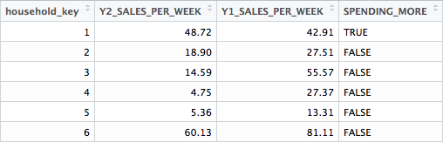

The graphs at the bottom of page 11 are weekly aggregate data, but they only include the decreasing trend households identified in the annual aggregates described above.